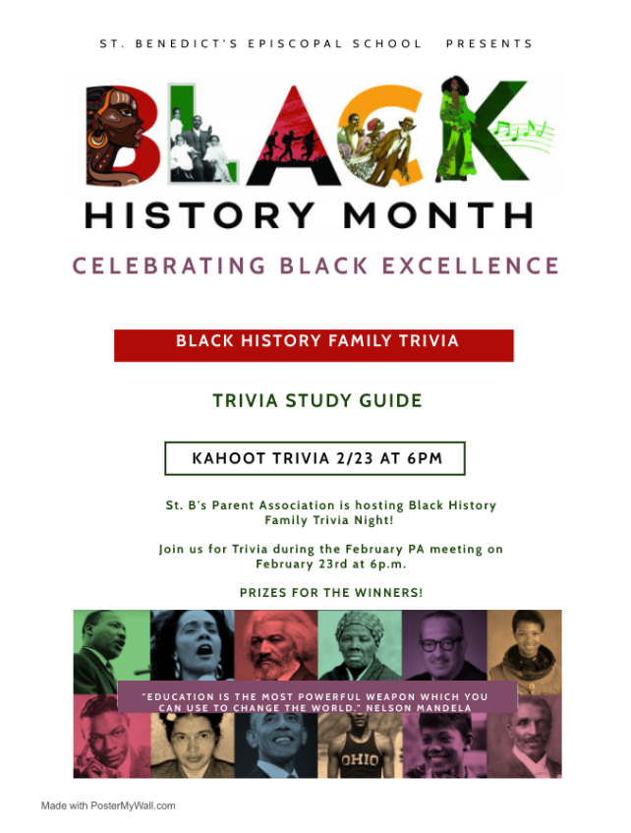
* PRIZE$ * PRIZE$ * PRIZE$ * PRIZE$ *

In celebration of the accomplishments of Black Americans, as we celebrate our Black heroes then and now, we are proud to highlight the following Black owned Smyrna businesses. Each has provided a prize for our Black History Family Trivia. Please join us for a chance to compete and win!!

Please support our sponsors and let them know you heard about them at St. B’s!!

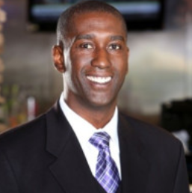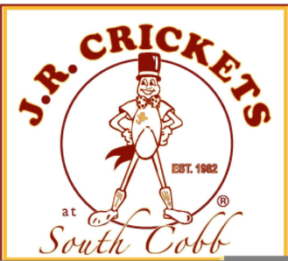
JR Crickets South Cobb is owned and operated by Trent Floyd. After spending 15 years as an accountant and financial analyst, Trent decided to hang up his hat in the corporate world and began his second career as a restaurateur opening JR Crickets South Cobb in October 2006. JR Crickets, known for its mouthwatering wings, has operated in Atlanta since its first location on Spring Street in 1982.

Trent Floyd
Owner and Operator of JR Crickets South Cobb
4479 South Cobb Drive, Smyrna, GA 30080, www.jrcricketssmyrna.com

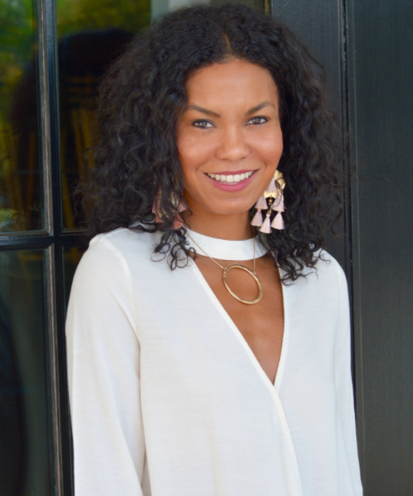
Mona Ariza is owner and operator of Hand In Pocket (HIP). HIP opened in the Summer of 2006 offering hip, casual, and fun wardrobe staples. Either shopping in store or online, you will find that Hand In Pocket is a sophisticated clothing retailer offering a unique mix of fashion, while staying true to its laid back roots.

Mona Ariza
Owner and Operator of Hand in Pocket Boutique
1675 Cumberland Pkwy SE, Ste 405, Smyrna, GA, 30080, www.handinpocket.com

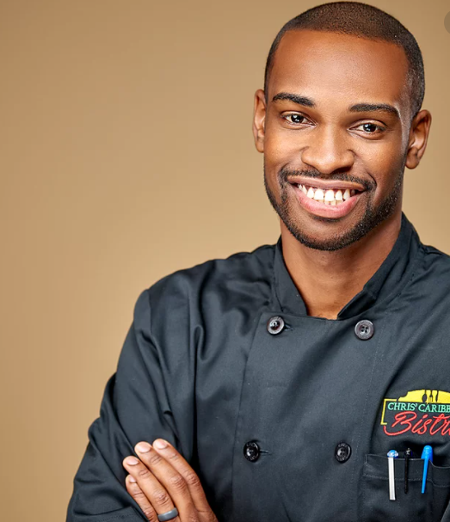
Ryan Campbell is the operator of the family ran business, Chris' Caribbean Bistro. Chris’ Caribbean Bistro was founded by Chris Campbell and is co-owned by his son, Ryan Campbell. They aim to elevate Caribbean cuisine in the Atlanta area and give people a new, unique taste of the islands.

Ryan Campbell
Co-owner and Operator of Chris Caribbean
Chris Caribbean Bistro
4479 South Cobb Drive, Smyrna, GA 30080, www.chriscaribbean.com

Stephanie & Adrian Eaddy are excited to introduce the St. B's community to their new business, Mosquito Hunters. With 20 years in Marketing and IT at large corporations the Eaddy's were looking for a way to have more impact in the community, create jobs and provide a much needed service to help families enjoy the outdoors pest free. Mosquito Hunters opens their doors in March of 2021 with a commitment to exceptional customer service.

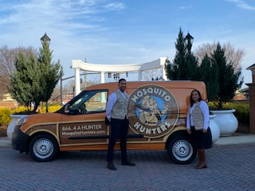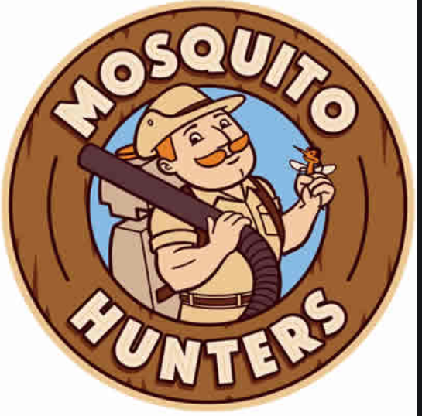

Stephanie and Adrian Eaddy
Owners and Operators of Mosquito Hunters & St. B’s Parents
www. mosquitohunters.com/buckhead-ga

McBride Sisters, Robin and Andréa’s, fueled by a shared passion for all things wine, wine-making and a desire to shake up the industry with a blend of old-world elegance and new-world finesse, founded McBride Sisters Wine in 2005. Over time, McBride Sisters has grown into the largest Black-owned wine company in the United States.

Robin and Andréa McBride
Founders of McBride Sisters Wine
**Total Wine & More provided an in-kind donation in celebration of Black History Month**
Akers Mill Square, 2955 Cobb Pkwy SE, Atlanta, GA 30339

Black History Family Trivia Study Guide

Alice Augusta Ball
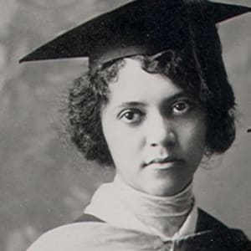
(1892-1916)
Chemist Alice Augusta Ball developed a successful treatment for Hansen's Disease, also known as leprosy. Ball was the first woman to graduate from the University of Hawaiʻi at Mānoa, where she earned a master's degree in chemistry. She then became the first African American researcher and instructor in the College of Hawaii chemistry department.

Patricia Bath

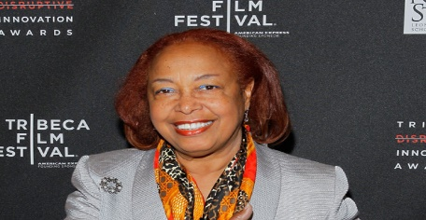
(1942 -)
Patricia Bath improved the vision of generations thanks to her invention for cataract treatment. In 1981, Bath invented the laser probe that precisely removed cataracts in a less-invasive way. In 1988, she became the first Black female doctor to receive a patent for a medical purpose.

Alexa Canady
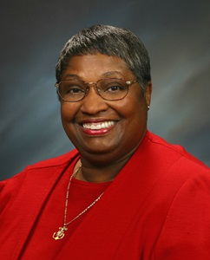

(1950 - )
Dr. Alexa Canady became the first African American woman neurosurgeon in the United States in 1981. Canady pursued neurosurgery while studying at the College of Medicine at the University of Michigan, where she graduated from in 1975. She became the first African American and first woman to be enrolled as a surgical intern at Yale-New Haven Hospital, as well as the first African American and first woman to graduate from the neurosurgical residency program at the University of Minnesota.

George Washington Carver
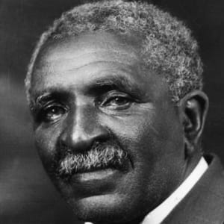
(1864 - 1943)
George Washington Carver was born enslaved and went on to become one of the most prominent scientists and inventors of his time, as well as a teacher at the Tuskegee Institute. Carver devised over 100 products using one major crop — the peanut — including dyes, plastics and gasoline.

Kizzmekia Corbett, Ph.D.

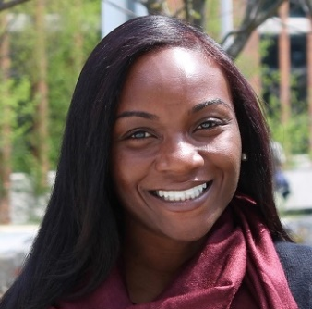
(1986 - )
Dr. Kizzmekia S. Corbett is a research fellow and the scientific lead for the Coronavirus Vaccines Team at the National Institutes of Health (NIH), National Institute of Allergy and Infectious Diseases, Vaccine Research Center. A viral immunologist by training, Dr. Corbett uses her expertise to propel novel vaccine development for pandemic preparedness.

Charles Drew
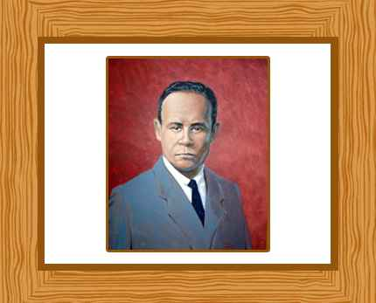
(1904 –1950)
Charles Richard Drew is called the "Father of the Blood Bank". As a surgeon, he pioneered research into the use and preservation of blood and plasma in World War II. His techniques for blood storage were adopted by the American Red Cross.

Mae C. Jemison
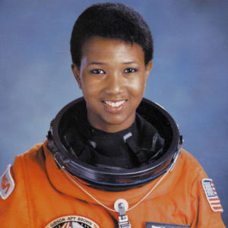
(1956 –)
Mae C. Jemison is an American astronaut and physician who, on June 4, 1987, became the first African American woman to be admitted into NASA’s astronaut training program. On September 12, 1992, Jemison flew into space with six other astronauts aboard the Endeavour on mission STS47, becoming the first African American woman in space.

Katherine Johnson
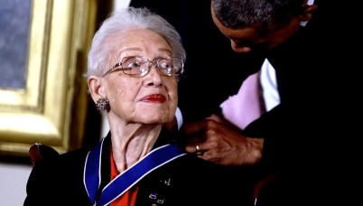
(1918 – 2020)
Katherine Johnson is best known for her major contributions to the United States' aeronautics and space programs with the early application of digital electronic computers. Her work was recently recognized and featured in the movie Hidden Figures.

Neil deGrasse Tyson
(1958 –)
One of America's best-known scientists, astrophysicist Neil deGrasse Tyson has spent much of his career sharing his knowledge with others. He has a great talent for presenting complex concepts in a clear and accessible manner. Tyson has served as host of NOVA ScienceNow and the StarTalk Radio podcast. He remains a popular TV science expert today and has amassed over 13 million followers on Twitter.

Dr. Daniel Hale Williams
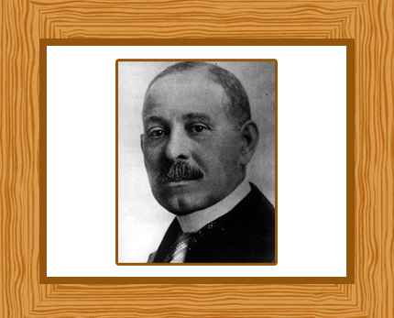

(1858 – 1931)
Dr. Daniel Hale Williams was the first cardiologist to successfully perform an open-heart surgery — to repair of the pericardium, the thin sac that encases the heart. Williams founded the first Black-owned hospital in the country but felt it was important to have interracial hospitals, where Black and White doctors could learn together. In 1891, Williams successfully opened the Provident Hospital and Training School for Nurses, the first interracial hospital and nursing school in the country.

